**CREATING NEW JOB IN JENKINS**

**Step 1:** 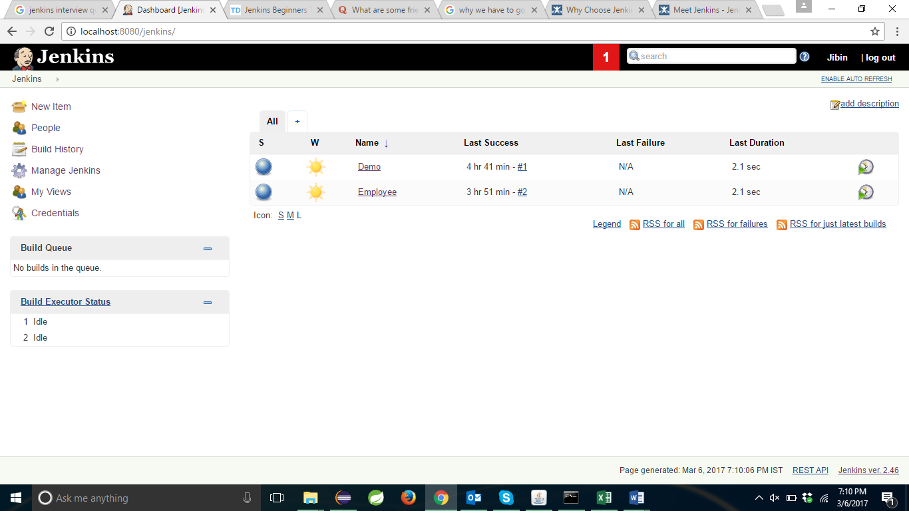

In this window click on New Item

**Step 2:** 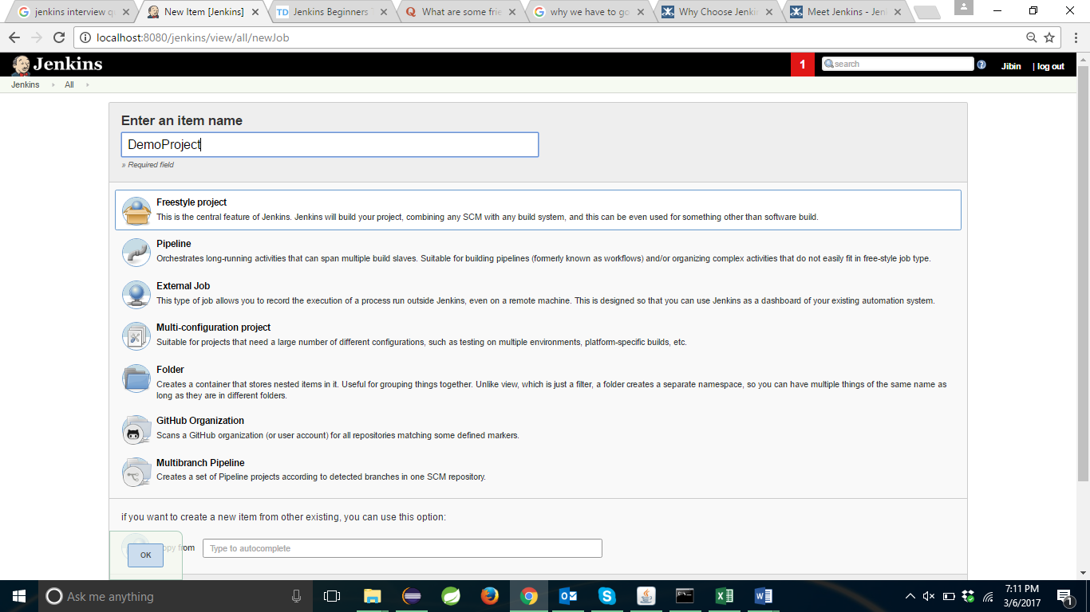

Give the Job name and select the type you have to create.Here I am selecting FreeStyle Project and click on OK.

**Step 3:**

Enter the details where you are managing the code and click on save.

**Step 4:**

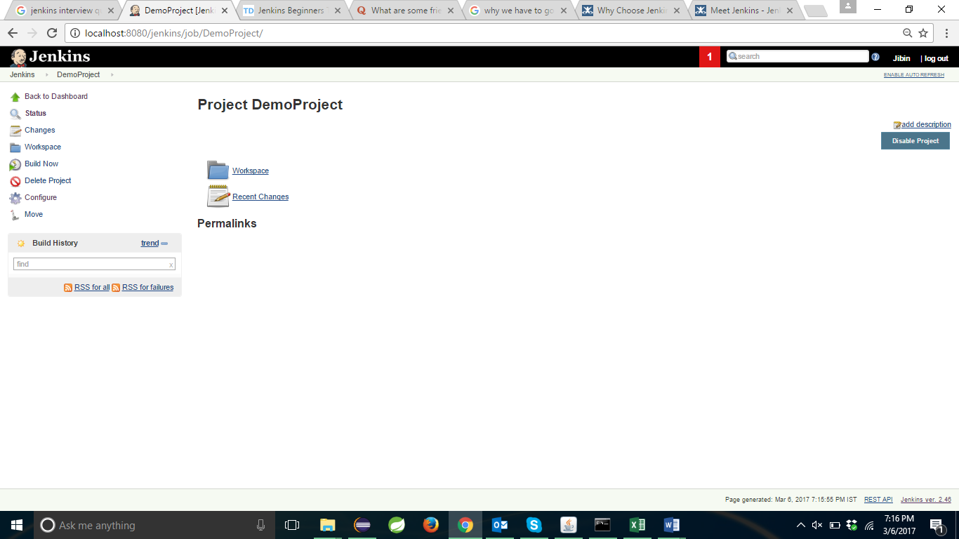

In this window click on build now.Now your build is created successfully.